**Module 13 Asssignment4 Conditional Statements**

**Introduction to conditional statements: if, else, elif.**

The if condition:

An if statement is a powerful control structure that allows you to execute a block of code only if a certain condition is true.

General syntax:

if condition:

# Code to execute if the condition is true

It’s important to note that the condition in an if statement must evaluate to either True or False. If the condition is True, the code block following the if statement will be executed. Otherwise, it will be skipped.

Example:

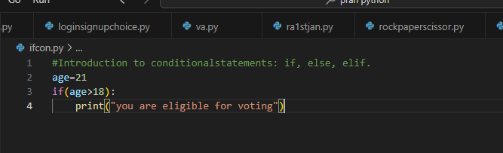

Output:

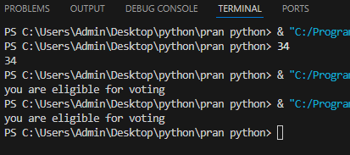

The else condition:

* The else block executes if the condition in the if statement is False.

General syntax for else condition:

if(condition):

#statement

else:

#false portion will be executed

Example for else statement:

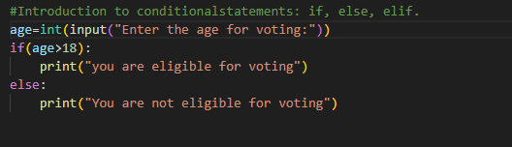

Output:

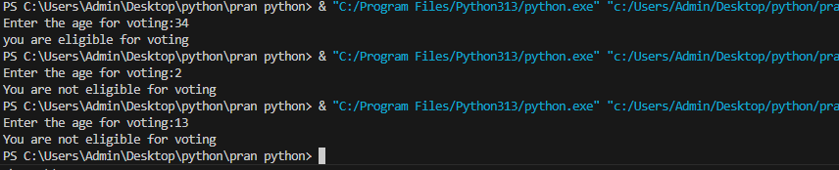

3)Elif statement:

The elif statement is also known as elseif statement.

elif checks multiple conditions. If the first condition is False, it checks the next condition.

General Syntax for elif statement:

if condition1:

# Code if condition1 is True

elif condition2:

# Code if condition2 is True

else:

# Code if none of the conditions are True

Example :

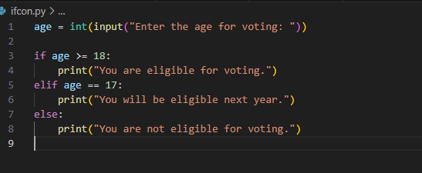

Output:

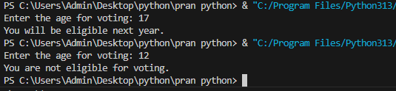

Nested if else

A **nested if-else** is an if-else statement placed inside another if-else statement. It allows for multiple conditions to be checked in a hierarchical manner. If the outer condition is true, the inner condition(s) are evaluated.

Syntax:

if condition1:

# Code block for condition1 being True

if condition2:

# Code block for condition2 being True

else:

# Code block for condition2 being False

elif condition3:

# Code block for condition3 being True

else:

# Code block for all conditions being False

Example:

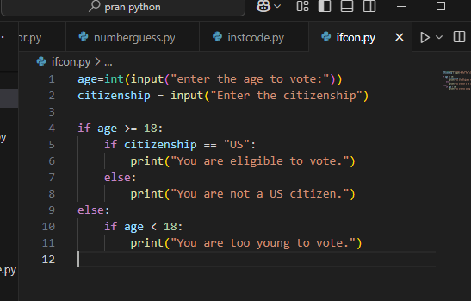

Output:

